PMOMax User Manual (Clean Version)
Katalyst Street — PMOMax Platform

Welcome to PMOMax
PMOMax is designed to help project managers, teams, and organizations quickly create professional Project Initiation Documents (PIDs). This manual explains how to use every key feature—uploading, editing, reviewing, and exporting project documentation—without technical jargon.

Supported File Types
PMOMax can read and parse the following file formats:
- Microsoft Word (.docx)
- PDF (.pdf)
- Text files (.txt)
- Excel workbooks (.xlsx)
- Markdown (.md)
- CSV (.csv)
You can upload, paste, or drag-and-drop any of these formats directly into the app.

Getting Started

System Requirements
- Chrome, Firefox, Safari, or Edge (modern versions)
- Minimum resolution 1280×720 (Full HD recommended)
- Internet connection for loading the app and using AI
- 10–20 MB free local browser storage

Launching PMOMax
- Open your browser and go to the PMOMax application URL.
- The homepage loads automatically—no login required for basic usage.
- Click Start New Project to begin or load demo data to explore features.

How to Upload, Paste, and Parse Documents

Upload a File
- Click Upload Document in the left panel or center panel.
- Select any supported file—Word, PDF, text, Excel, markdown, or CSV.
- PMOMax will automatically parse the file content and extract PID fields.
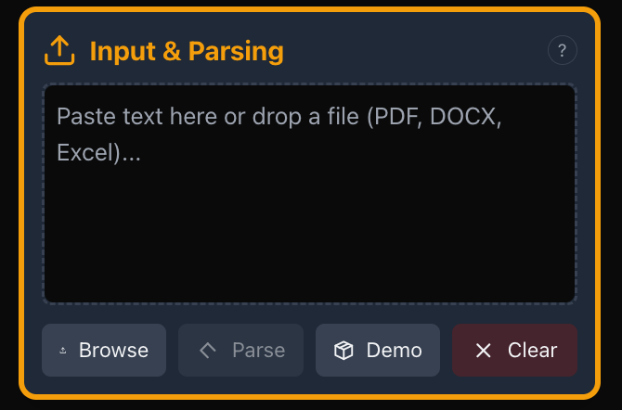

Paste Text
- Click inside the parsing area.
- Paste text directly (Command/Control + V).
- Click Parse to allow the system to identify each PID section.

Large Document Handling
- If files exceed ~300 KB, PMOMax warns you before parsing.
- The system will still attempt parsing but may take longer.
- AI will validate whether parsing is accurate.

If Parsing Fails
PMOMax will automatically:
- Try the local parser.
- If it finds no headings or structure, it switches to AI analysis.
- If AI parsing also fails, PMOMax notifies you and suggests a cleanup.

Understanding the Interface

PMOMax has three main panels:

1. Left Sidebar
- Section navigation (Overview, Scope, Schedule, Risk, Resources, Communication, Quality).
- General notes area.
- Scrolls independently from the main content.
- Shows section status indicators: complete, partial, empty.
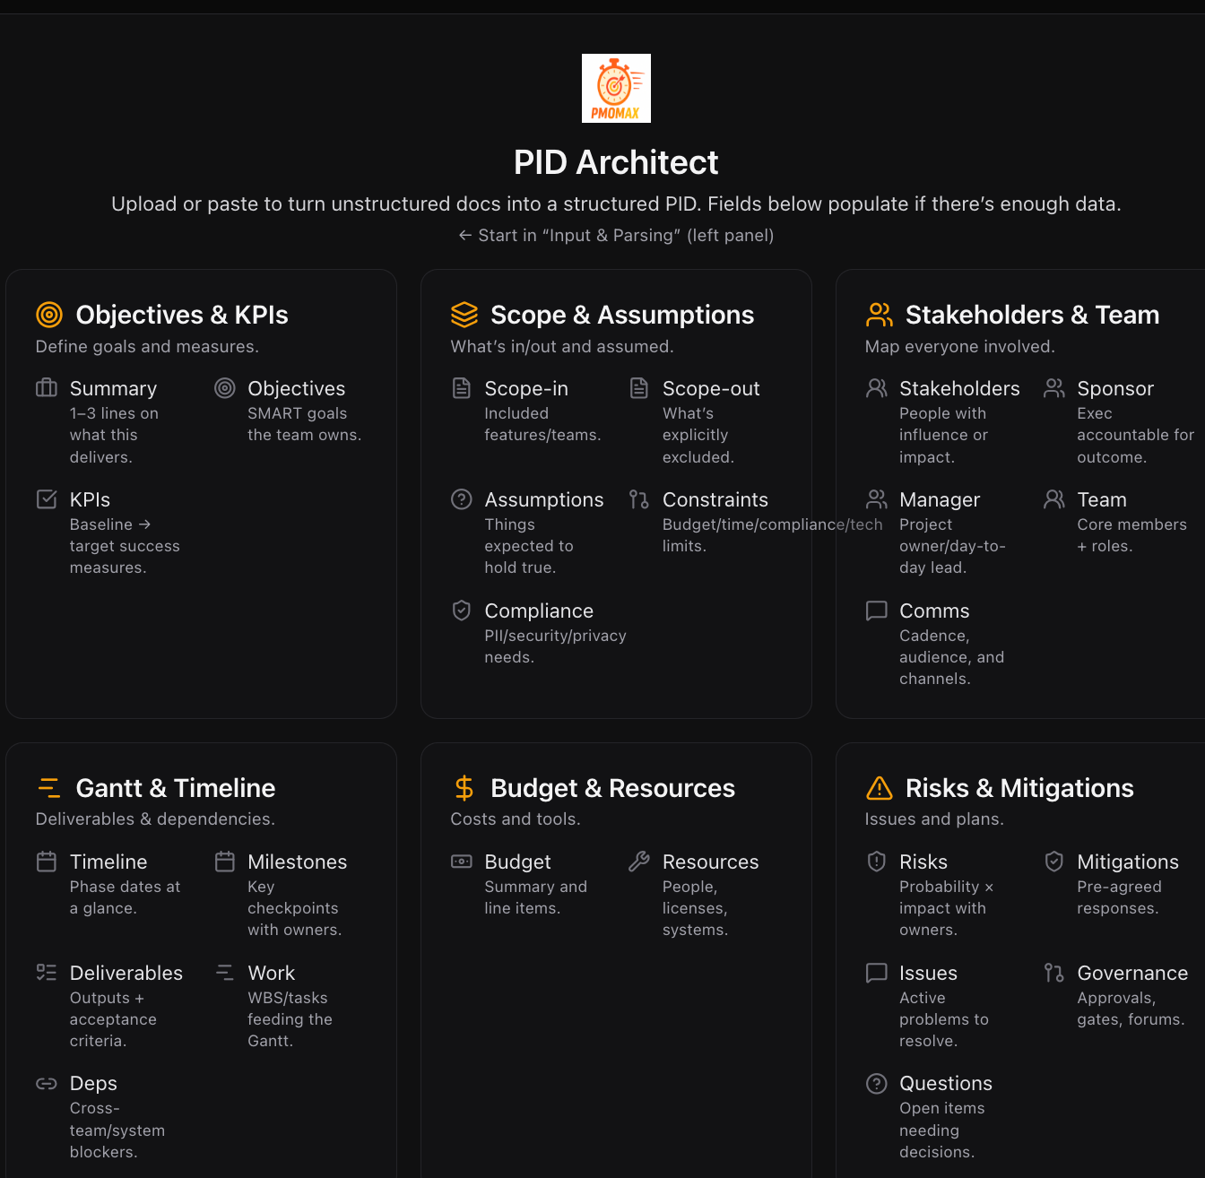

2. Center Input Panel
- The main editing area.
- Each PID field includes:
  - Section title and description
  - Input boxes
  - Editable tables (Deliverables, Milestones, Budget, Risks, Communication Plan, etc.)
  - Charts such as Gantt view
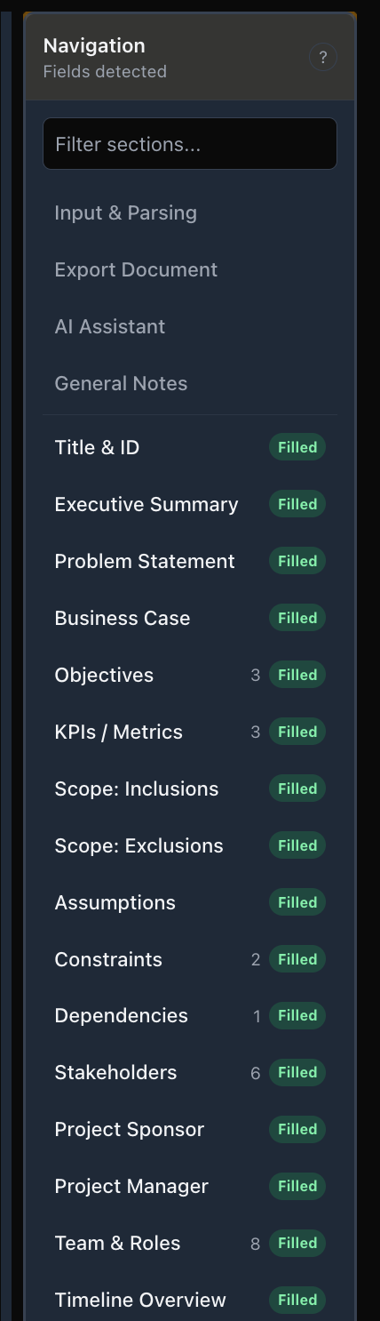

3. Left Output Panel
- Live preview of the final PID document.
- Exports (PDF, Word, JSON).
- Print view.

Creating Your First PID

Step 1 — Enter Basic Details
- Open Project Overview.
- Fill in:
  - Project Title
  - Summary
  - Objectives
  - Business Case
  - Stakeholders

Step 2 — Continue Through Sections
PMOMax includes seven structured sections:
- Project Overview
- Scope & Deliverables
- Schedule & Milestones
- Resources & Budget
- Risk Management
- Communication Plan
- Quality & Change Control
Each section includes clear fields, templates, tables, and examples.

Working With Tables
Tables share consistent controls:
- Add Row — opens an inline form
- Edit Row — pencil icon
- Delete Row — trash icon with confirmation
- Sort — click any column header
- Filter — search or filter icon
- Export — CSV download of the table
- Keyboard shortcuts for editing and navigation
PMOMax tables include:
- Deliverables
- Milestones
- Resource Allocation
- Budget
- Risk Register
- Stakeholder Communication

Using the Gantt Chart
PMOMax includes an interactive Gantt builder:

Add Phases
- Name the phase
- Select start and end dates
- Choose a color
- Add progress

Add Tasks
- Assign to a phase
- Add assignees
- Progress percentage
- Dependencies

Edit Visually
- Drag timelines left/right
- Drag edges to adjust duration
- Toggle high-level or detailed view

Export the Gantt
- PNG
- PDF
- Excel
- Select date ranges and formatting options

AI Assistant
The AI Assistant helps by:
- Suggesting content for any field
- Reviewing existing content
- Creating risks, milestones, deliverables, or summaries
- Improving clarity and structure

Where It Appears
- Right panel slide-out
- Activated via robot icon or keyboard shortcut

Good Prompts
- “Suggest risks for a healthcare project.”
- “Improve my business case.”
- “Give milestone ideas for a 90-day project.”

Exporting Your Work
PMOMax supports exporting:

PDF
- Best for final distribution
- Includes page numbers, headers, table of contents
- Fully formatted

Word (DOCX)
- For editing, collaboration, branding
- Maintains structure, headings, and tables

JSON
- Use for backups
- Can restore into PMOMax later

Print View
- Direct browser printing

Data Management

Auto-Save
- Saves every 2 seconds
- Stored locally in browser storage
- Works offline once loaded

Manual Save
- Ctrl/Cmd + S

Import / Export JSON
- Export JSON to save complete project data
- Import JSON to load a previous project

Clear Project
- Resets all content
- PMOMax warns before deletion

Troubleshooting

Parsing Issues
- Ensure the document has clear headings
- Try uploading instead of pasting
- Try PDF → Word conversion for garbled files

Gantt Chart Blank
- Ensure at least one phase exists
- Ensure dates are valid

AI Assistant Slow
- Check your internet
- Reload
- Try a simpler prompt

Performance Problems
- Close extra browser tabs
- Reduce table size
- Clear localStorage if nearly full

Best Practices
- Write clear, measurable objectives
- Keep deliverables focused and specific
- Update progress weekly
- Use Gantt presets for different audiences
- Export PDF for stakeholder review
- Use JSON backups regularly
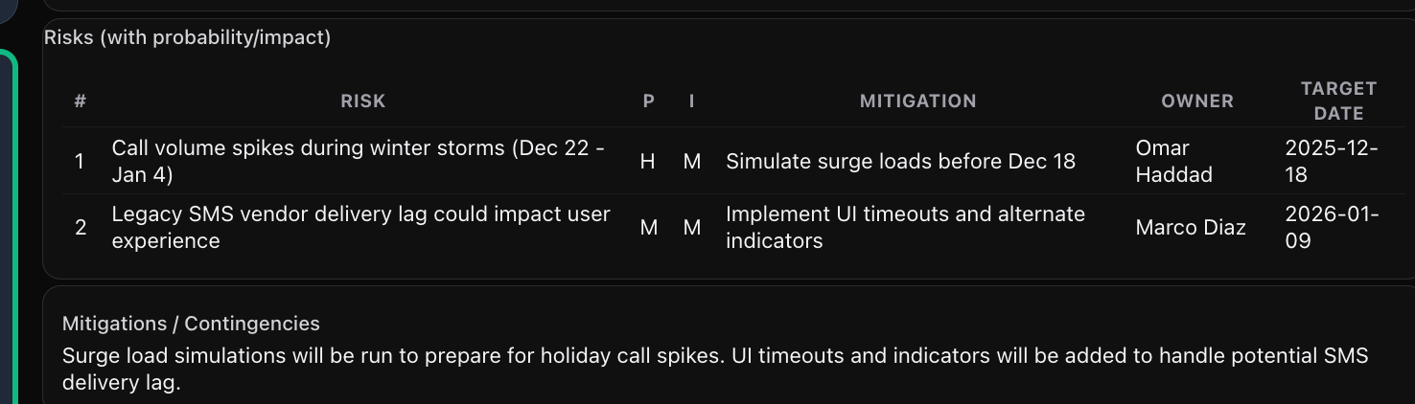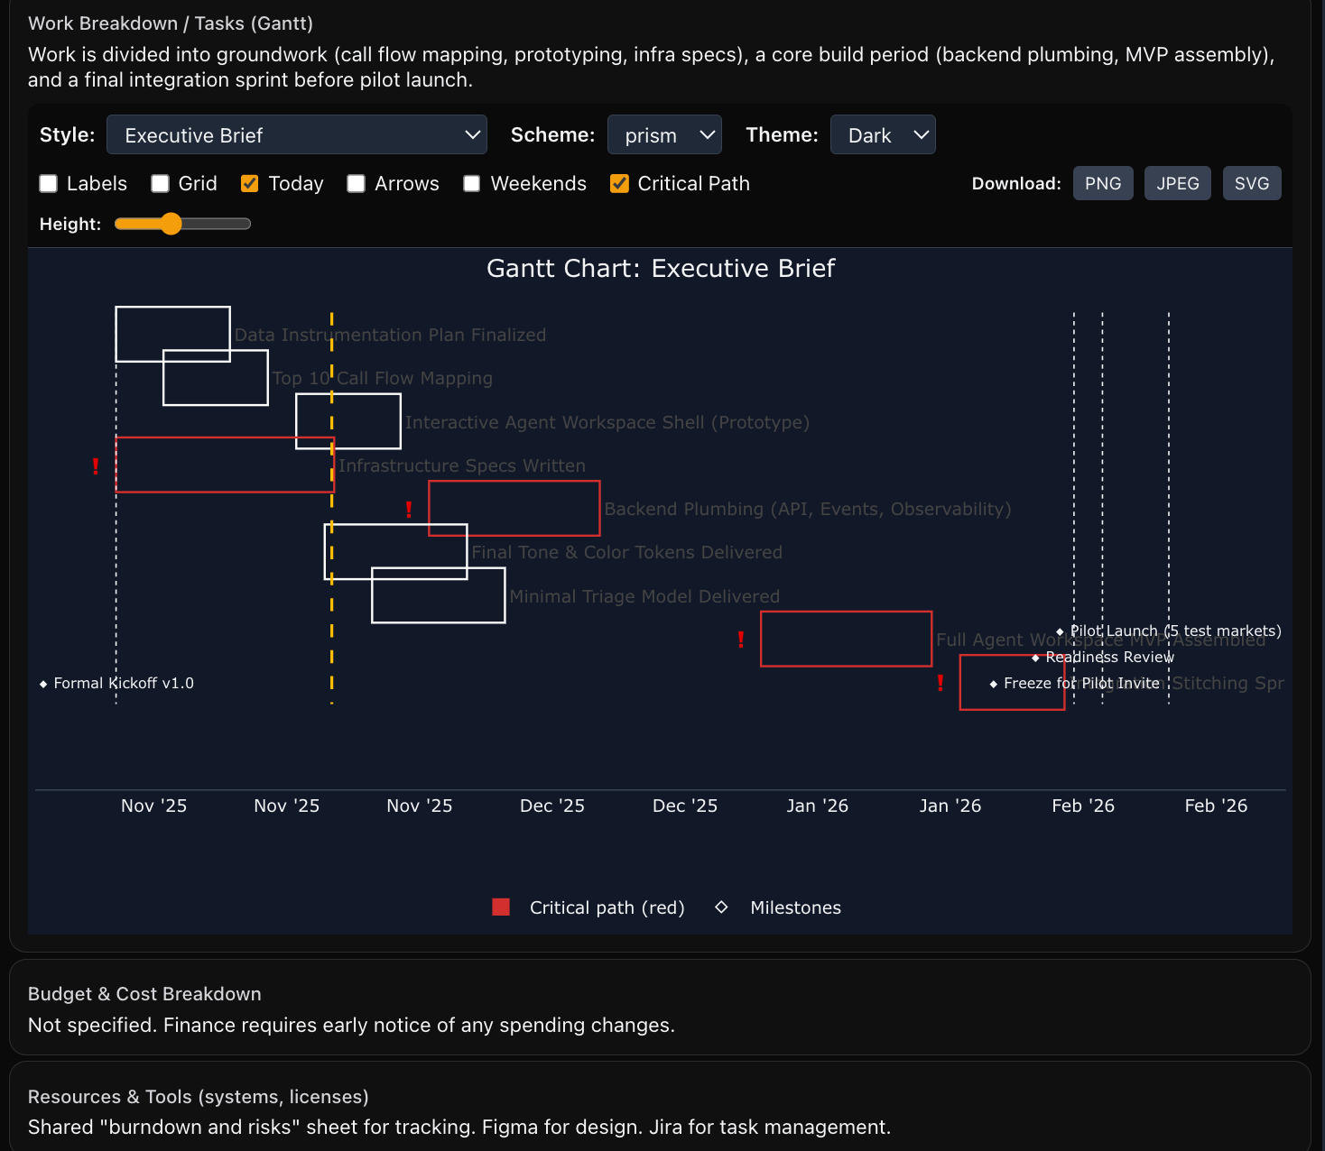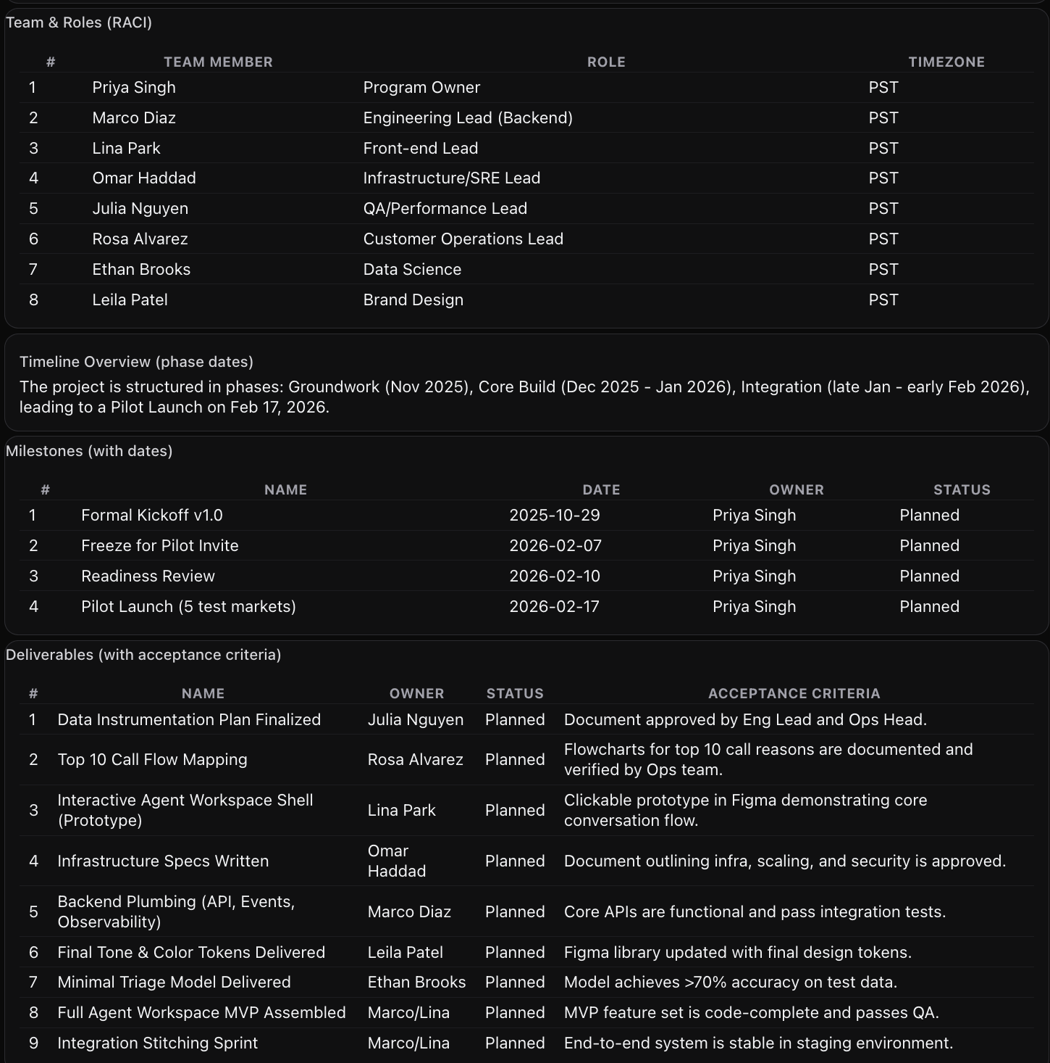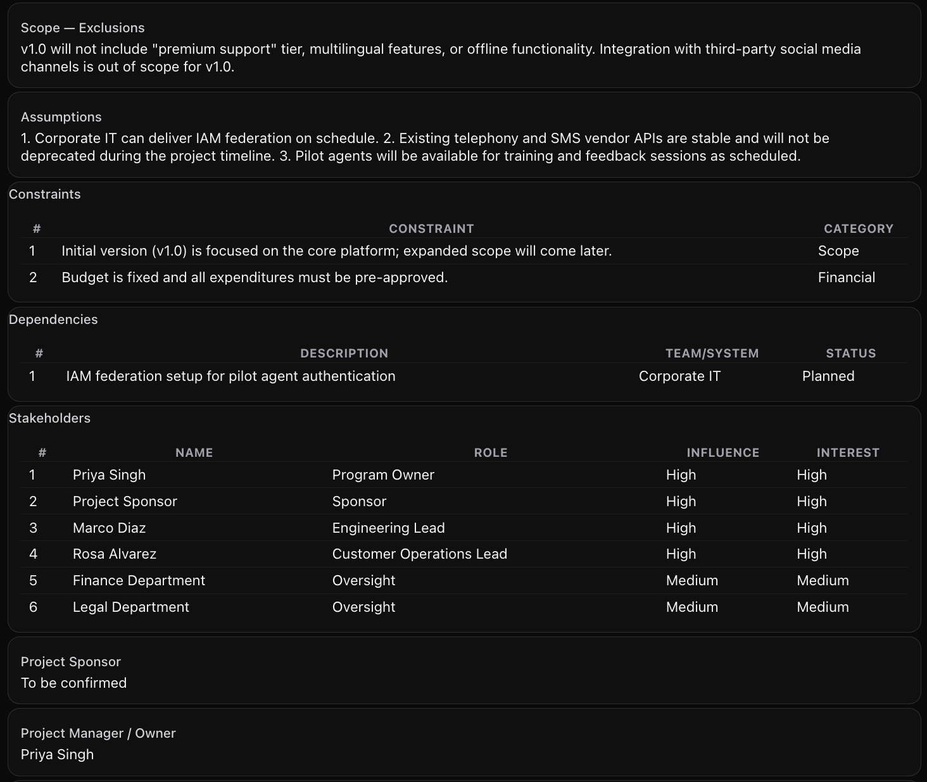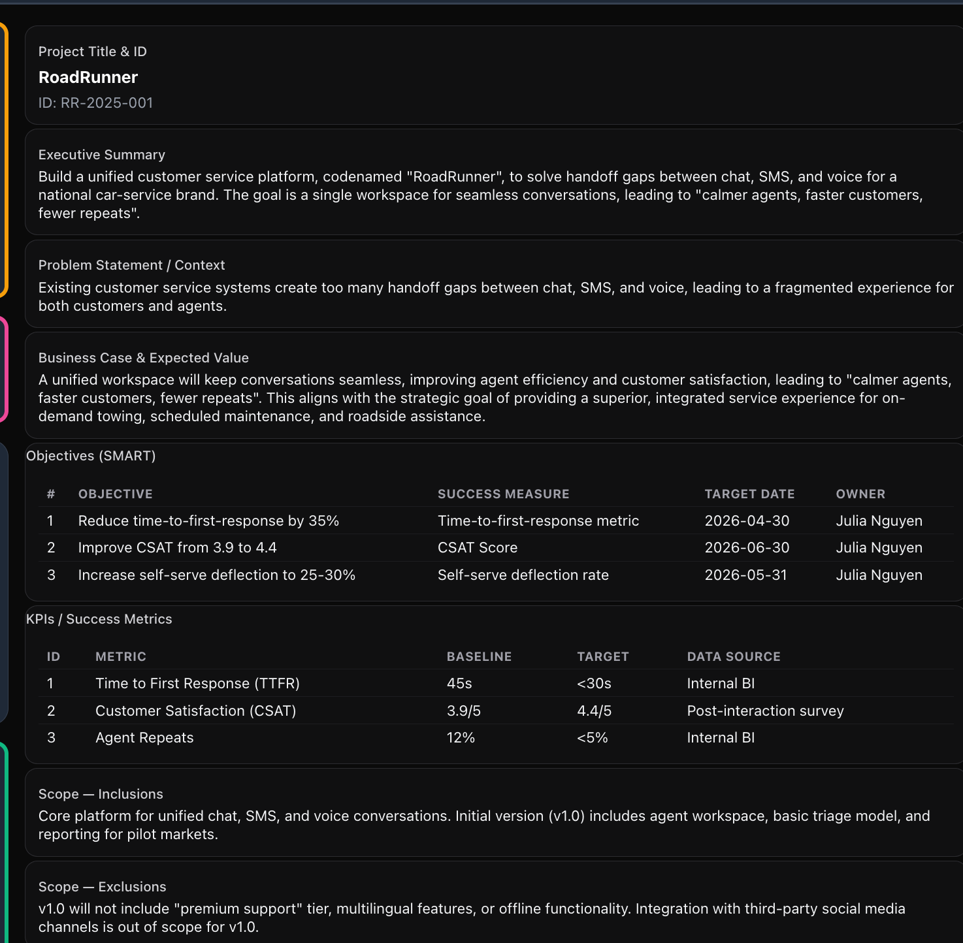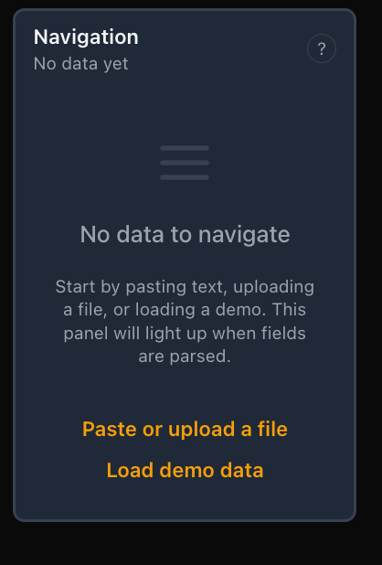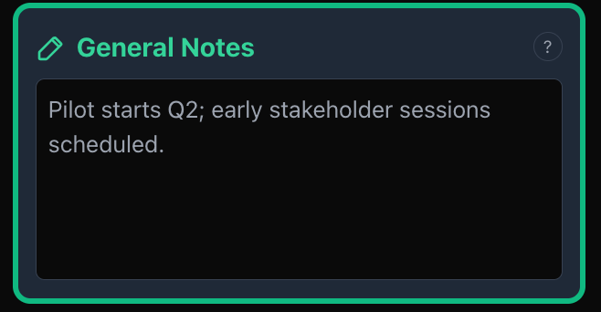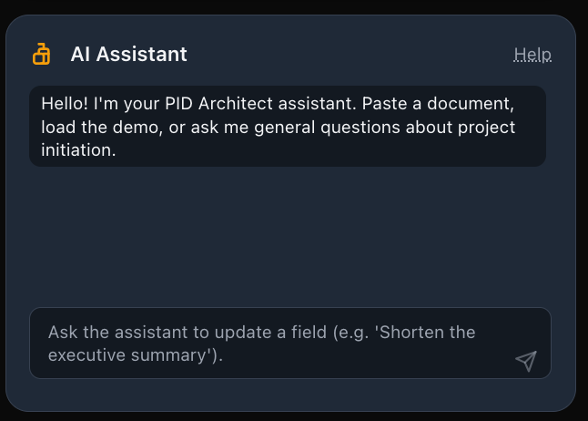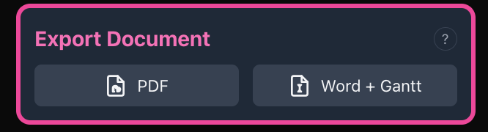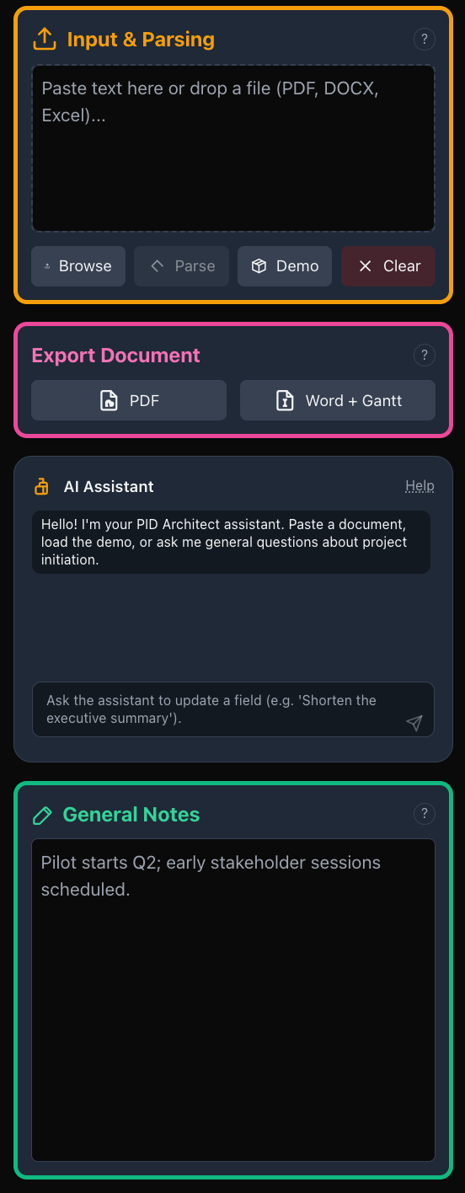perly embedded
Just say:
“Generate the files.”

